group policies and procedures

patient restrictions policy

Category | Clinical
Author | Castleman Healthcare Ltd
Responsible Director | Dr Dominic Hennessy
Date of issue | December 2022
Next review date | September 2025
Document ref & version | Patient Restrictions Policy V1
Related policies and guidance

Document revision and approval history
Version | Date | Author | Approved by | Comments
V1 | Dec 2022 |  | JL/FP
 | Sep 2023 |  |  | Reviewed DH

Document Summary
It is the responsibility of Castleman Healthcare Ltd, its employees, attached staff, staff working for the federation but employed by a member practice or staff working for the company (henceforth called “the staff member”) to identify, determine and protect oral or written information which is regarded as confidential.
Castleman Healthcare Ltd will, from time to time, find its staff members working from the practice or location where family members or friends are registered. Staff members, the practices, the Trusts and the Federation and/or Castleman Healthcare Ltd. have a responsibility to ensure that the confidentiality of said family and friends is maintained and that the staff members in question are never in a situation where they have to treat family or friends or come into contact with their family or friends’ confidential information.

Responsibilities of the Staff Member
All staff must understand their responsibilities regarding confidential information and be vigilant for breaches, or potential breaches, of the security of information written or otherwise. Confidentiality awareness training is the responsibility of the PCN, or the employing organisation if not the PCN and forms a part of the induction of new staff and should be undertaken on an ongoing basis at staff meetings.
Managers are also responsible for monitoring compliance with this policy and for taking appropriate action in the event of a breach which will lead to disciplinary action.
Where staff are aware that their family or friends are registered, they must disclose this information to their Practice Manager.
The staff will sign the attached document (Appendix A) which gives assurances that in no circumstances will they see, treat or access the records of their family member of friends. A breach of this assurance will result in disciplinary proceedings.
Additionally, no employed member of staff can be registered at the practice they work at as patient.

Responsibilities of Castleman Healthcare Ltd
Castleman Healthcare Ltd should ensure that the staff are never expected to see, treat, visit etc. the family member or friend under any circumstances, nor have to carry out any administrative duties on these patients.
Castleman Healthcare Ltd should instigate the following on the SystmOne clinical system to restrict access to the records of those people disclosed by the staff member.

Systmone instructions
Restricting a patient record
- Search for the patient and open their record

- Along the Tree go to the administrative tab

- Then go to

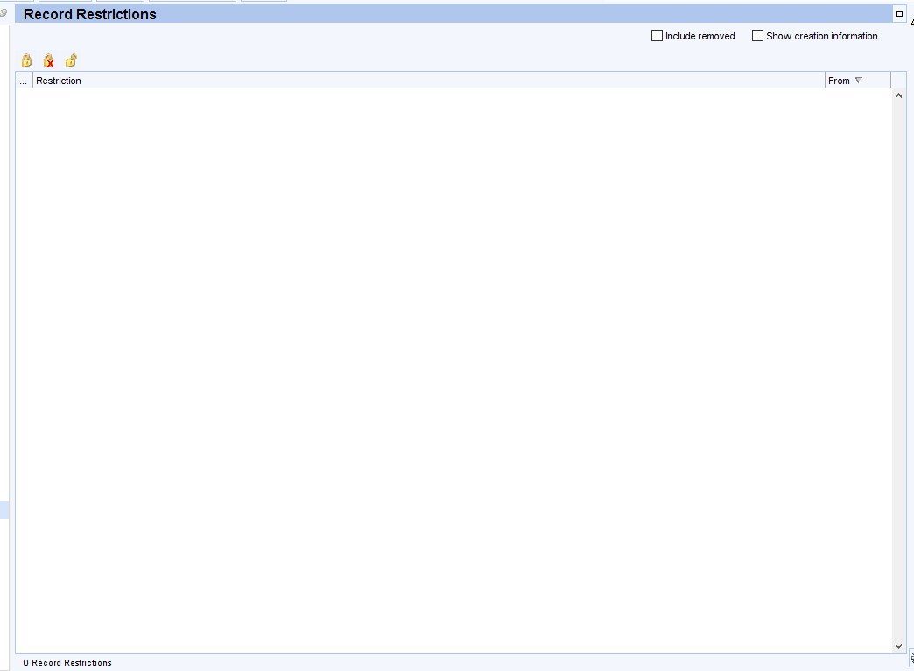
If the patient already has restrictions, they will be listed in the white box
- To record a new restriction, click on the padlock icon

- It will then pop-up with the “Add Record Restriction” box:

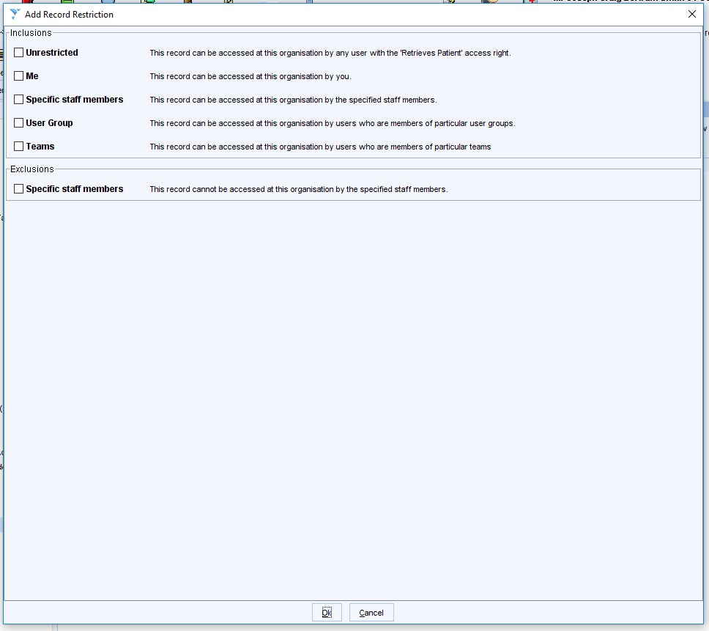
Inclusions: Specific staff members: You can set the staff members that can access that patients record. When you tick the box, it will drop down another box for you to add the staff members:
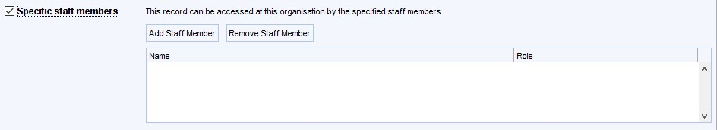

Inclusions: User Group: You can set specific user groups to be able to access the record. When you tick the box, it will drop down another box for you to add the user groups, you can add more than one user group.
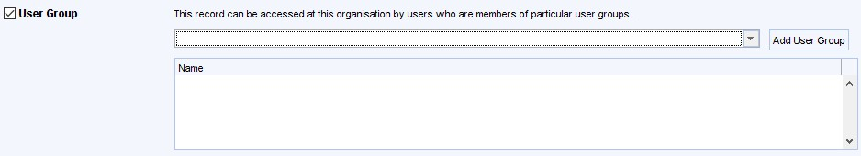

Exclusions: Specific staff members: This option lets you set staff members that cannot access the patients record. When you tick the box, it will drop down another box for you to add the staff members:
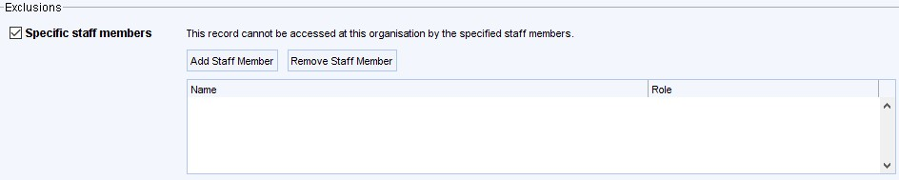

Press “Ok” to save

To remove restrictions if needed:
If there are any restrictions, they will be listed in the white box
Click on restriction you want to remove and using the padlock symbols along the top, press the padlock with a cross to remove the selected restriction or the unlocked padlock to removal all restrictions.

Save the patient record to save any change.

appendix A – disclosure form
NAME OF STAFF MEMBER:
POSITION:

To: The Practice Manager of: _____________________________ (Practice Name)
I disclose that I am aware that the following patients are known to me as either family members or friends and therefore I understand that it is inappropriate for me to see, treat, or view the records of these patients and I understand that should I do so this is result in disciplinary proceedings against me.

Signed: ___________________________

Print: ____________________________

Date: ____________________________

Name of Patient | Date of Birth / Address | Relationship | Practice

I ______________________________________ (Practice Manager) confirm that the records of these patients have been restricted in accordance with this policy.

Signed_________________________________ (Practice Manager)

Date: __________________

