group policies and procedures

information sharing policy

Category | Information Corporate Governance
Author | Castleman Healthcare Ltd
Responsible Director | Fiona Pickering
Date of issue | September 2021
Next review date | September 2025
Document ref & version | Information Sharing Policy V2
Related policies and guidance

Document revision and approval history
Version | Date | Author | Approved by | Comments
V1 | Sep 2016 | FP |  | Need to discuss information sharing policy further – no changes made at this stage by FC
Final | Sep 2016
 | Apr 2018 |  |  | Reviewed by JL
 | Aug 2019 |  |  | Reviewed JL
V2 | Sep 2021 |  |  | Reviewed and amended by FP
 | Sep 2023 |  |  | Reviewed FP

Aim
The adoption of formal policy and resulting good practice for the sharing of information with key stakeholders will lead to confidence in Castleman Healthcare Ltd, its commissioning bodies and the general public. Effective information exchange is the key to the safe delivery of clinical care. Sharing information meets the requirements of statutory and local initiatives and is vital for coordinating services between partner organisations. Appropriate information sharing builds trust and good relationships between partners.

Responsible information sharing brings together services that reveal a more accurate picture of an individual’s health. The streamlining of information sharing enables care to be delivered quickly, efficiently, safely and accurately. It also enables commissioners and providers to get a greater level of understanding about how services are operating across the borough. Overall, this improves analysis, decision-making, resource allocation and better use of public funds.
Barriers to effective information sharing include:
- Misconceived ideas, particularly data protection legislation.
- A lack of guidance and plain language explanations.
- An absence of formal protocols between partners.
- A tendency to take an overly cautious approach.
- A lack of awareness of the benefits.
Castleman Healthcare Ltd will ask for and keep information, so that patients receive correct care and treatment when needed and for as long as they need it.
Castleman Healthcare Ltd also needs to share information to ensure:
- That all services meet patients’ needs, now and in the future.
- That payment terms are fulfilled correctly.
- That cross – organisation pathways can be reviewed and high standards maintained.
- Recognition of staff training requirements and educational needs.

Procedure
Each time Castleman Healthcare Ltd is asked or wishes to share information, the following thought process is undertaken (as taken from the Information Sharing: Practitioners’ guide, HM Government, 2015)

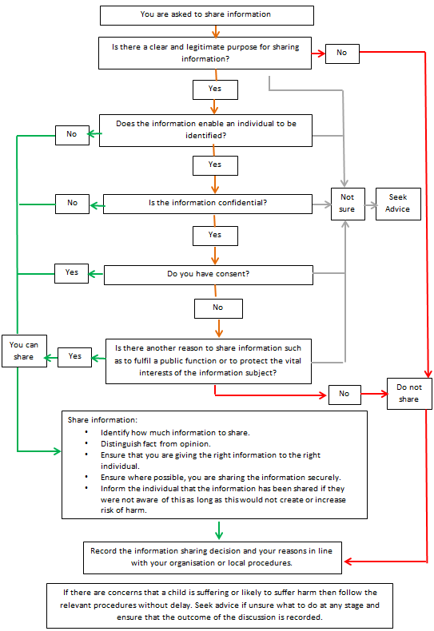

Information Sharing relationships
Due to the nature of business, there is only a few occasions where Castleman Healthcare Ltd has a need to share or request information from other bodies. The movement of person identifiable information is documented on the internal patient information flow chart, including Safe Haven locations. For details on how to safely share information with NHS or other organisations, please refer to the Information Governance Policy.

Other than for legal purposes, Castleman Healthcare Ltd does not share person identifiable data.

